SUMMERVILLE CREDIT UNION · CONSOLIDATED MEMBER GUIDE
Credit Cards

Module: nFinia Digital Banking > Cards > Credit Card Accounts
01 PRODUCT SUMMARY

Summerville Credit Union offers Visa credit cards to eligible members, providing a flexible revolving credit line for everyday purchases, travel, and larger expenses. Credit cards are managed through the same Cards section of online banking as debit cards, giving you a unified view of all your payment cards in one place.
From online banking, you can view your credit card balance, available credit, current and past statements, reward points (on eligible cards), minimum payment due, and payment history. You can make payments, set up automatic payments, and manage card controls — all from the Cards section or your credit card account view.

At a Glance
Attribute | Detail
Card Network | Visa
Access in OLB | Cards section > select your credit card
Information Available | Balance, available credit, statement, minimum payment, due date, rewards
Payments | Make one-time or recurring payments from linked accounts
Card Management | Card Controls, Set PIN, Deactivate / Replace, Link to Digital Wallet
Related Features | View Card Details, Card Controls, Auto Payment, Credit Card Loans

02 KEY USE CASES

Use Case | Who Uses It | What They Do | Business Value
View credit card balance | Member checking current balance or available credit | Navigates to Cards and selects credit card | Balance, available credit, and payment due date displayed instantly
Make a payment | Member making a monthly payment | Uses Quick Transfer or navigates to credit card account to initiate payment | Payment processed from the selected source account
Redeem reward points | Member with a rewards credit card | Views points balance in Card Details and follows rewards redemption process | Accumulated points redeemed for cash back, travel, or merchandise
Apply for a credit card | Prospective member or member without a current card | Applies via the Apply for Loans section on the Dashboard | Application reviewed; card issued upon approval

03 STEP-BY-STEP GUIDE

Navigation: Log in to Summerville Credit Union online banking. Click Cards in the top navigation bar and select your credit card, or navigate to Accounts to view the credit card account.
Step 1 — Arrive at the Dashboard
After logging in, you land on the Dashboard showing your account balances, recent payments, and quick-action shortcuts. Your credit card is listed alongside your debit cards in the Cards section. You can also access it from the Accounts section.
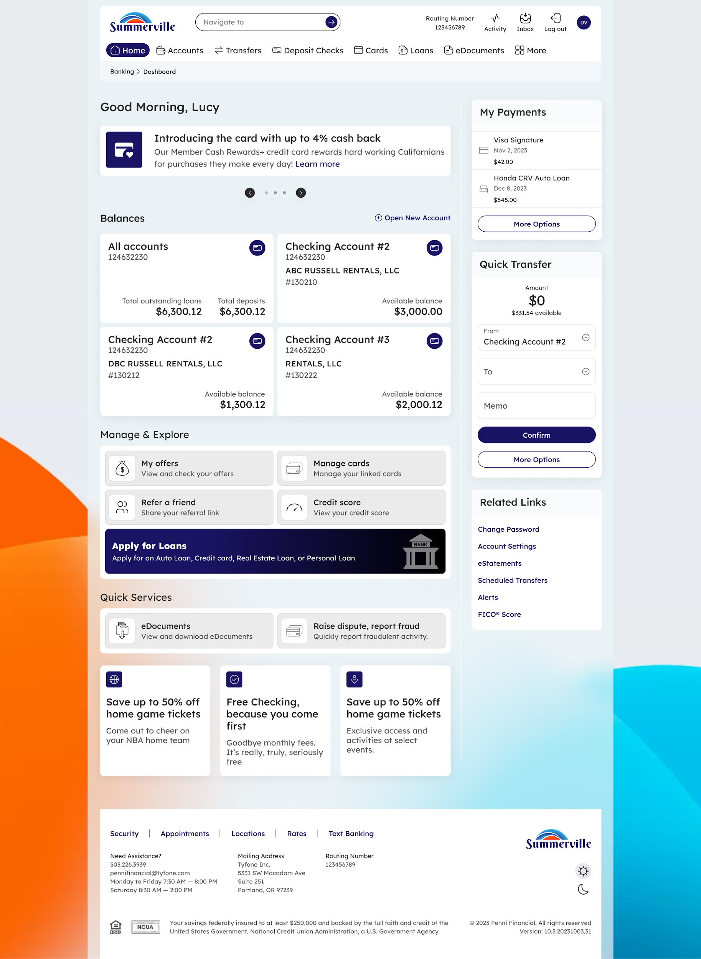
Step 1: Dashboard — starting point for navigation
Step 2 — View Credit Card Details and Make a Payment
On the Cards page, select your credit card. The card tile shows your available credit, current balance, minimum payment due, due date, and reward points. To make a payment, use the Quick Transfer widget on the right sidebar — select your credit card as the destination and your checking or savings account as the source. Enter the payment amount and click Confirm.

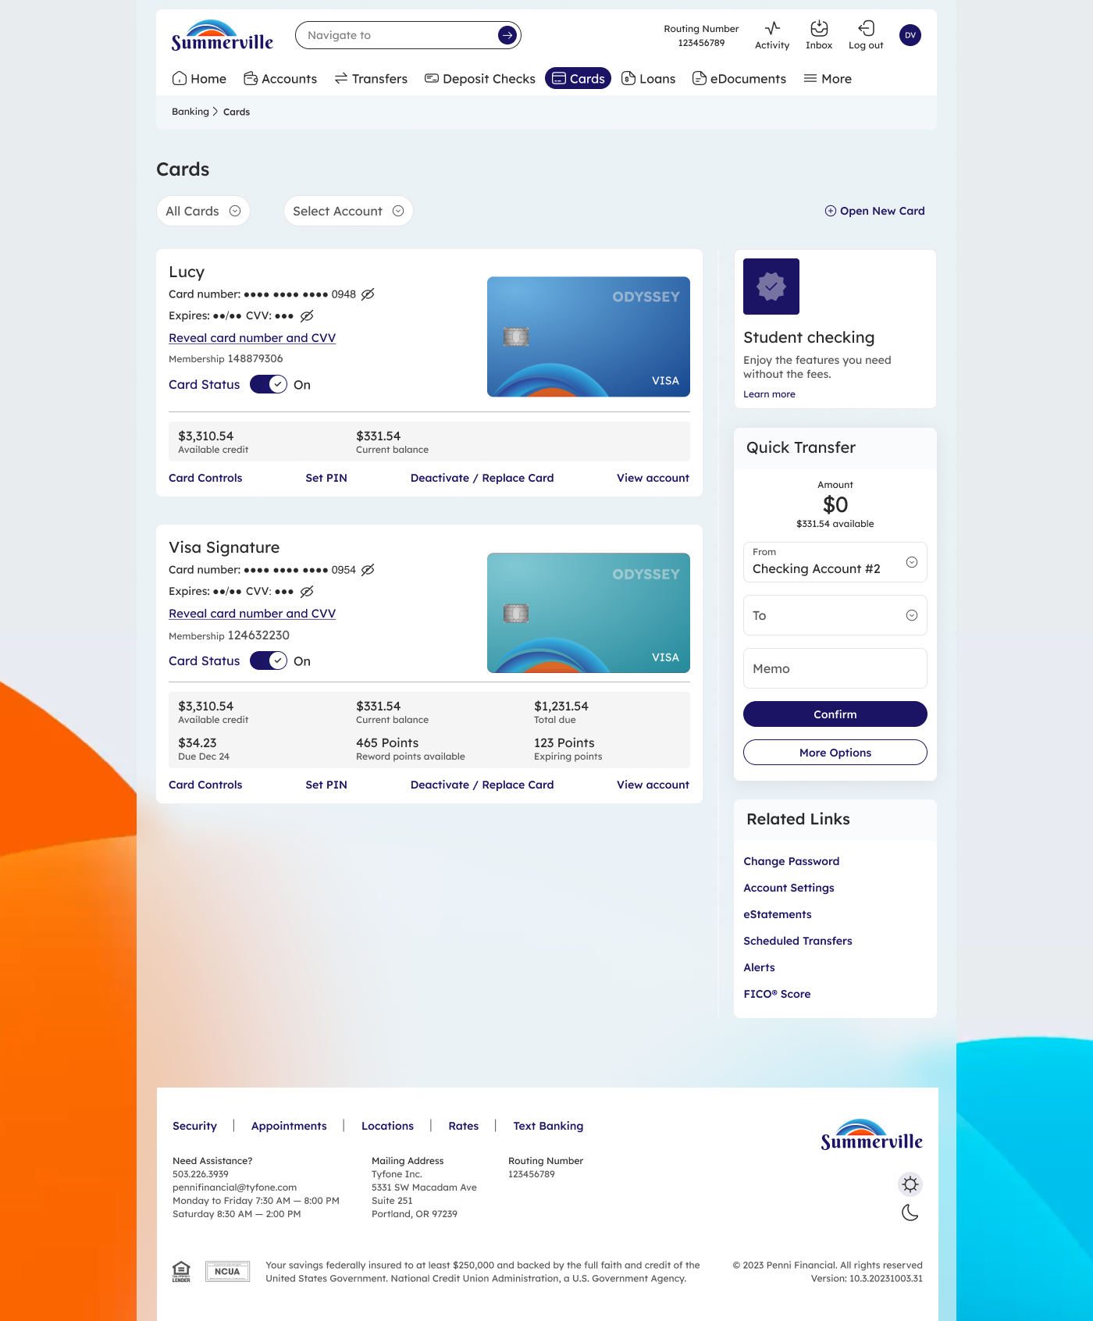

Step 2: Credit card displayed in the Cards list with balance and quick action links
Note: Set up Automatic Payment from your credit card account settings to ensure you never miss a payment. Even setting up auto pay for the minimum payment amount will protect your credit score.

